Test Plan (demo-opencart.com)

Objective 2

Scope 2

In-Scope 2

Out-of-Scope 2

Modules 2

Test Environments 3

Assumptions 3

Test Deliverables 3

Risks 3

Entry Criteria 3

Exit Criteria 3

Test Strategy 4

Testing Approach 4

Testing Type 4

Black box (Functional) 4

Test Data 4

#### 

*Created By: Ibrahim Imtiaz*

# Objective

The objective of this Software quality inspection is to detail the manual testing performed on the **Registration, Login, and Search** modules of the e-commerce website, OpenCart.com. The testing included usability, functional, error handling, and cross-browser evaluations using black-box techniques like boundary value analysis and equivalence partitioning. The goal is to provide concise test cases, a requirements traceability matrix (RTM), bug reports, and a final summary of the testing results.

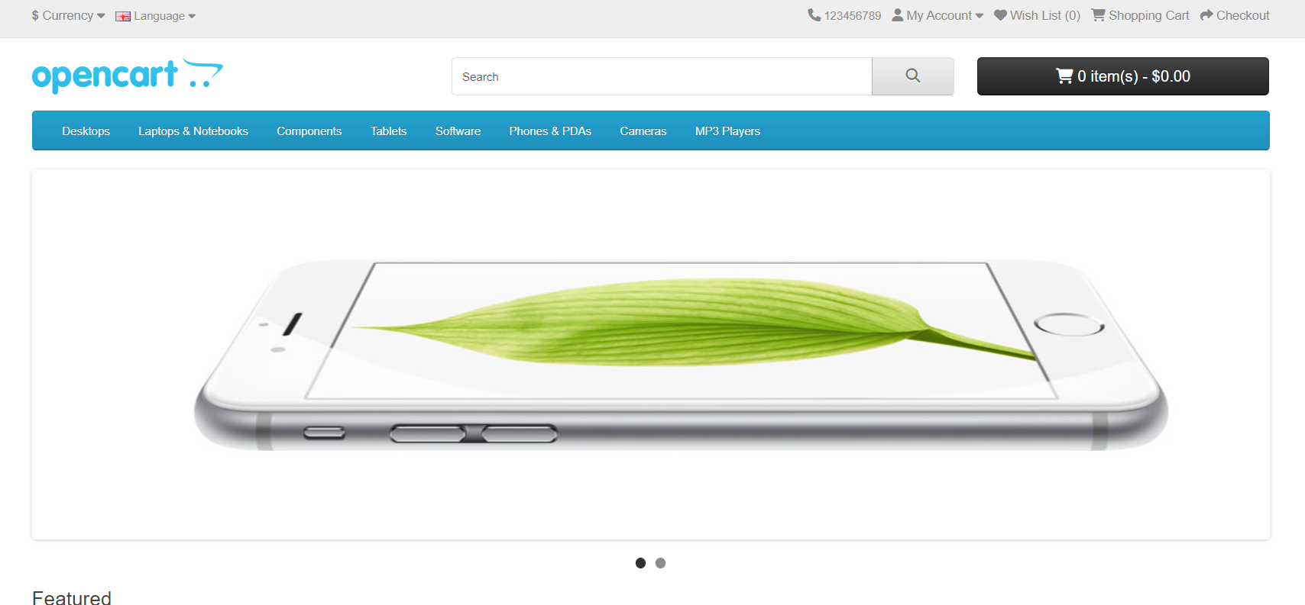

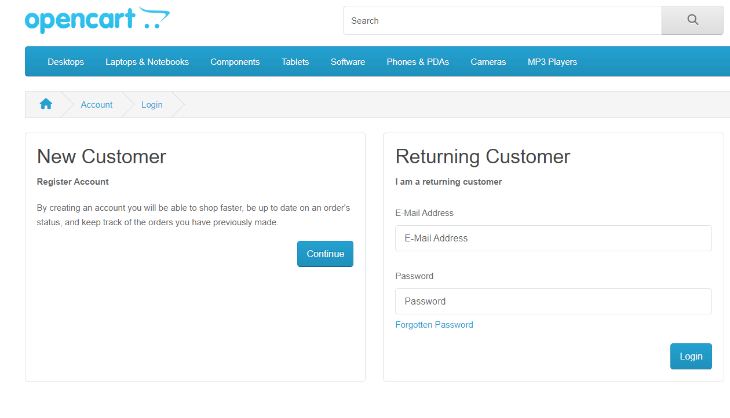

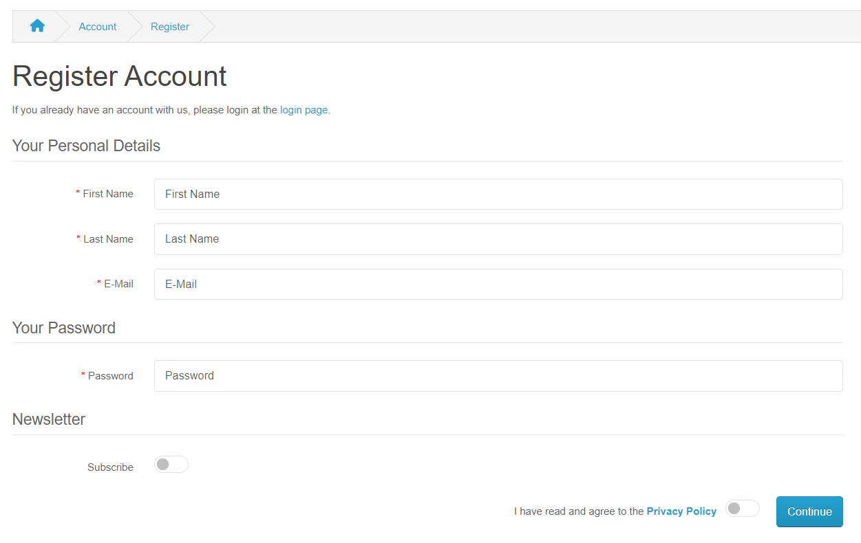

# Scope

## In-Scope

* User Registration
* User Login
* Product Search and Filtering

## Out-of-Scope

* Backend API testing
* Backend testing

# Modules

1. User Registration
2. User Login
3. Product Search and Filtering

# Test Environments

* Windows 10 – Chrome, Firefox and Edge
* Mac OS – Safari Browser
* Android Mobile OS – Chrome
* iPhone Mobile OS - Safari

# **Assumptions**

* Test environment is stable and mirrors the production environment.
* Test data provided is valid and relevant.

# **Test Deliverables**

* Test Cases
* Traceability Matrix (RTM)
* Bug Reports in Jira
* Final Test Summary Report (PowerBi Reporting)

# **Risks**

* Unavailability of the test environment.
* Incomplete or unclear requirements.

# **Entry Criteria**

* Test environment is set up and accessible.
* Test data is prepared and validated.

# **Exit Criteria**

* All critical test cases are executed.
* No open critical defects.
* Test summary report is reviewed and approved.

# **Test Strategy**

## **Testing Approach**

* **Functional Testing**
* **Usability Testing:**
* **Cross-Browser Testing**
* Error Handling Testing:

# Testing Type

## Black box (Functional)

* Boundary Value Analysis
* Equivalence Partitioning Test Cases

## **Test Data**

* Use a mix of valid and invalid data for different test cases (e.g., valid credit card details for payment, invalid credentials for login).